VRCopter : source : <http://www.diydrones.com/profiles/blogs/vr-copterx4-with-vr-brushless-gimbal-a-good-entry-level-platform>

* VR Copter Frame .
* VR oring anti vibration system.
* VR Copter Landing Gear
* [VR Gimbal Frame and Electronic for GoPro Hero 3.](http://www.virtualrobotix.com/page/vr-gimbal)
* GoPro 3 Hero Silver
* [VR Brain 4.5](http://www.virtualrobotix.com/page/vr-brain-v4-0)
* 4 MK3639 motor
* 4 ESC with SimonK Firmware
* 3DR GPS
* 3DR Telemetry KIT
* 4 APC 12 Propeller.
* 10 Amp 3S battery flight time around 20 min without payload until 24 min.

**ardupilot 2.5 quadcopter with FVP setup**

ardupilot 2.5 on the frame x525 v3 with props 11x4.7

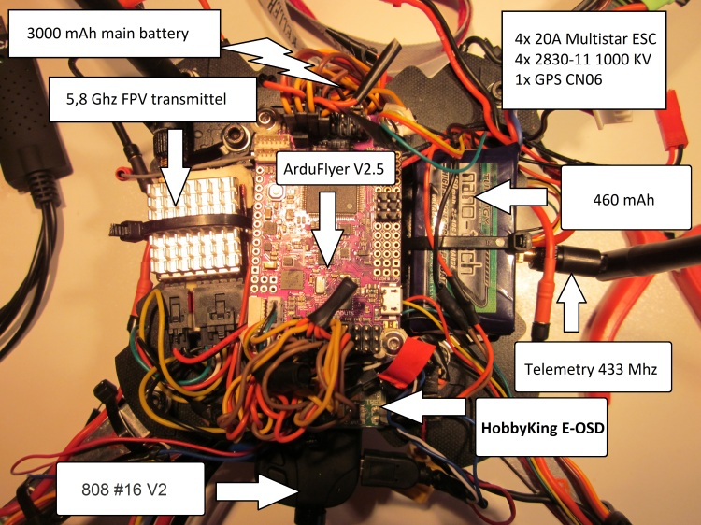

# My 97minute:06second record quadcopter flight source : <http://www.diydrones.com/profiles/blogs/my-97minute-06second-record-quadcopter-flight>

Quadcopter details:

-Custom CF frame built from 12mm tubes and 1m~3mm CF plate.

- RCTimer 17x5.5 CF Props

- Turnigy Plush 12A ESC's running BLHeli firmware

- RCTimer 5010 - 360Kv motors

- Panasonic NCR18650 13,600A battery pack

- Bareduino Arduino FC with MPU6050

- OrangeRX DSM satellite RX

- AUW 1296 grams with battery

- Frame AUW is 499 g

My best result is 31 min. 1150 gr the total weight, 6400 MAh/3s, 800 kV motors, 12x5,4 inch props

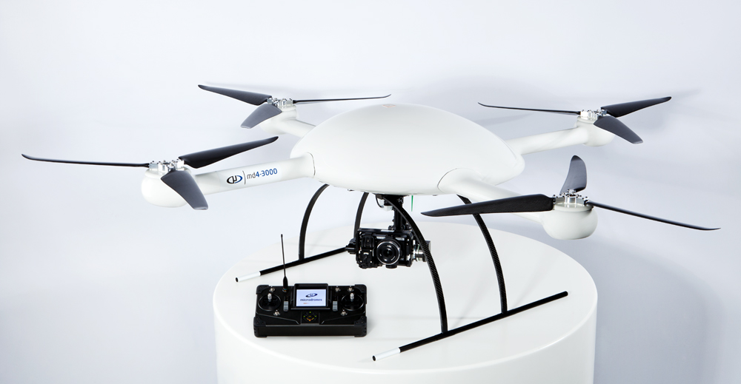<http://www.diydrones.com/profiles/blogs/microdrone-md4-1000-incredible-flight-time> 80min !